

Cyberster Internship Program

Internship Report
TRACK: BLUE TEAM
NAME: MUHAMMAD RAZA
INSTRUCTOR: ABDULLAH ZIA
ROLL NUMBER: CSI-B1-121
WEEK 10: Autopsy Triage, Artifact Hunting, and Timeline Reconstruction

1. Executive Summary
This report details the forensic examination of the Mantooth.E01 disk image, belonging to the primary suspect, Wes Mantooth. The investigation focused on uncovering evidence related to a fraudulent check-cashing scheme.
Conclusion: The analyzed artifacts conclusively establish that this machine was actively used to facilitate financial fraud and identity forgery. Evidence recovered includes searches for "check washing", local storage of forged identity documents, usage of high-quality photo printers, and direct communication with known co-conspirators.

2. Evidence Integrity & Case Setup
To ensure admissibility, the evidence image was ingested into Autopsy with strict integrity checks applied.

2.1. Evidence Verification
- Evidence File: Mantooth.E01
- Data Source Hash: 31217210a1a69f272079a3bde3d9d8fc (MD5)
- Verification: The calculated hash matched the acquisition hash, confirming the image is unaltered.
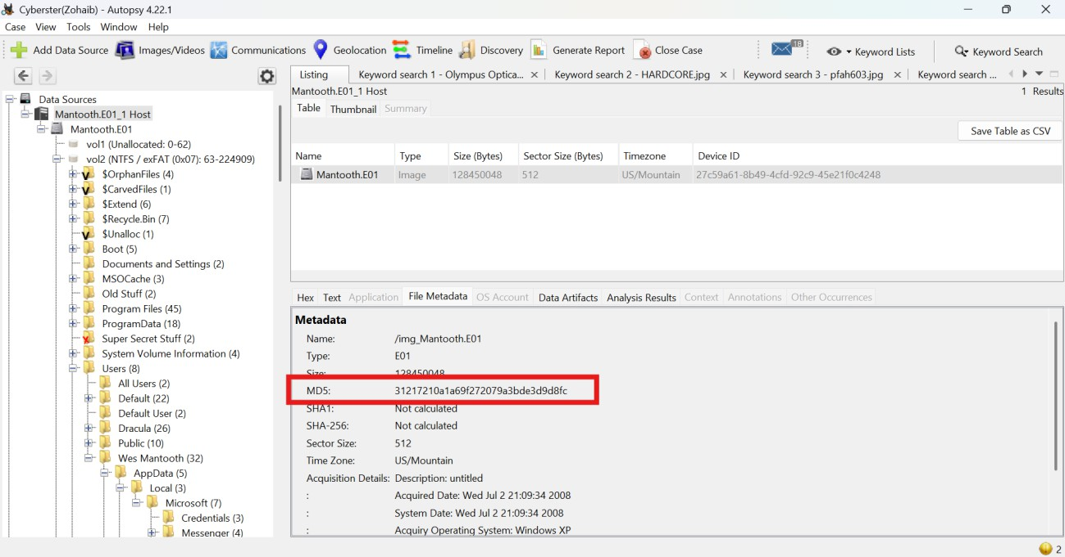

2.2. Disk Partition Structure
The image contained four volumes. The primary Windows installation and user data were located on vol2 (Sector 63 to 224,909, NTFS).
Volume | File System | Sector Range | Role
vol1 | Unallocated | 0 to 62 | Pre-partition space
vol2 | NTFS (0x07) | 63 to 224,909 | Primary OS & User Data Partition
vol3 | DOS FAT12 | 224,910 to 240,974 | Secondary FAT partition
vol4 | Unallocated | 240,975 to 250,879 | Post-partition slack

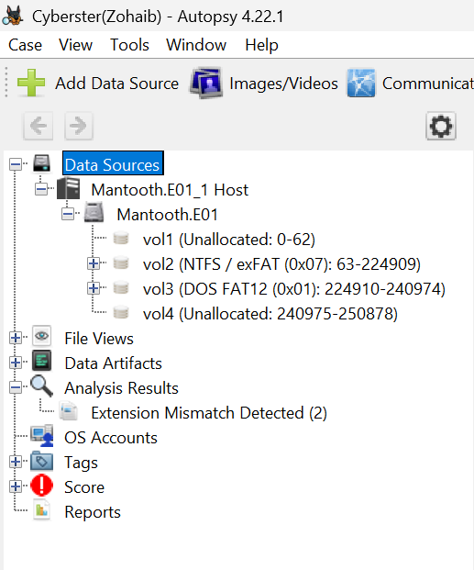

3. Forensic Findings
The investigation targeted specific vectors associated with financial fraud: intent (browser history), execution (printers/forgery), and conspiracy (communications).

3.1. Browser History & Intent
Analysis of the web history indicates premeditated intent to commit financial crimes.
- Key Search Terms: "check washing", "atm card stealing"
- External Media Activity: Evidence shows the suspect accessed a file named ATM_THEFTS1.ppt directly from an external drive, indicating active research into ATM vulnerabilities.
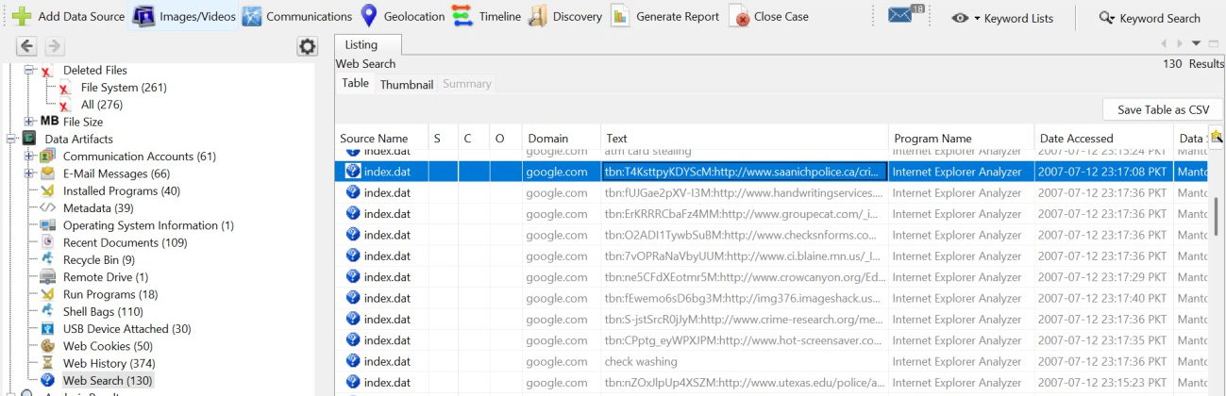

3.2. Document Forgery & Physical Printing
The suspect utilized this machine to physically produce fraudulent materials.
- Identity Forgery: The Scripts folder contained high-resolution image files indicating identity theft/forgery, specifically: national_id.jpg, prescriptions.jpg, and national_id_back.jpg.
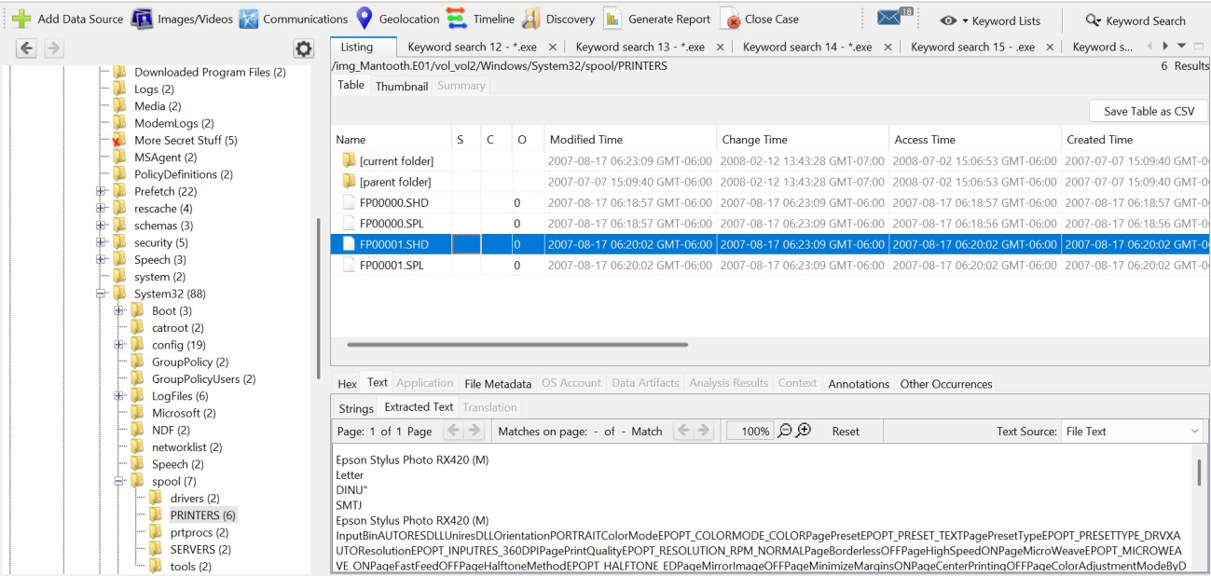
- Print Spool Logs: Autopsy recovered print spool files proving that documents were physically printed from this machine to an Epson photo printer. The use of a high-quality photo printer is highly consistent with producing fraudulent checks and forged IDs.
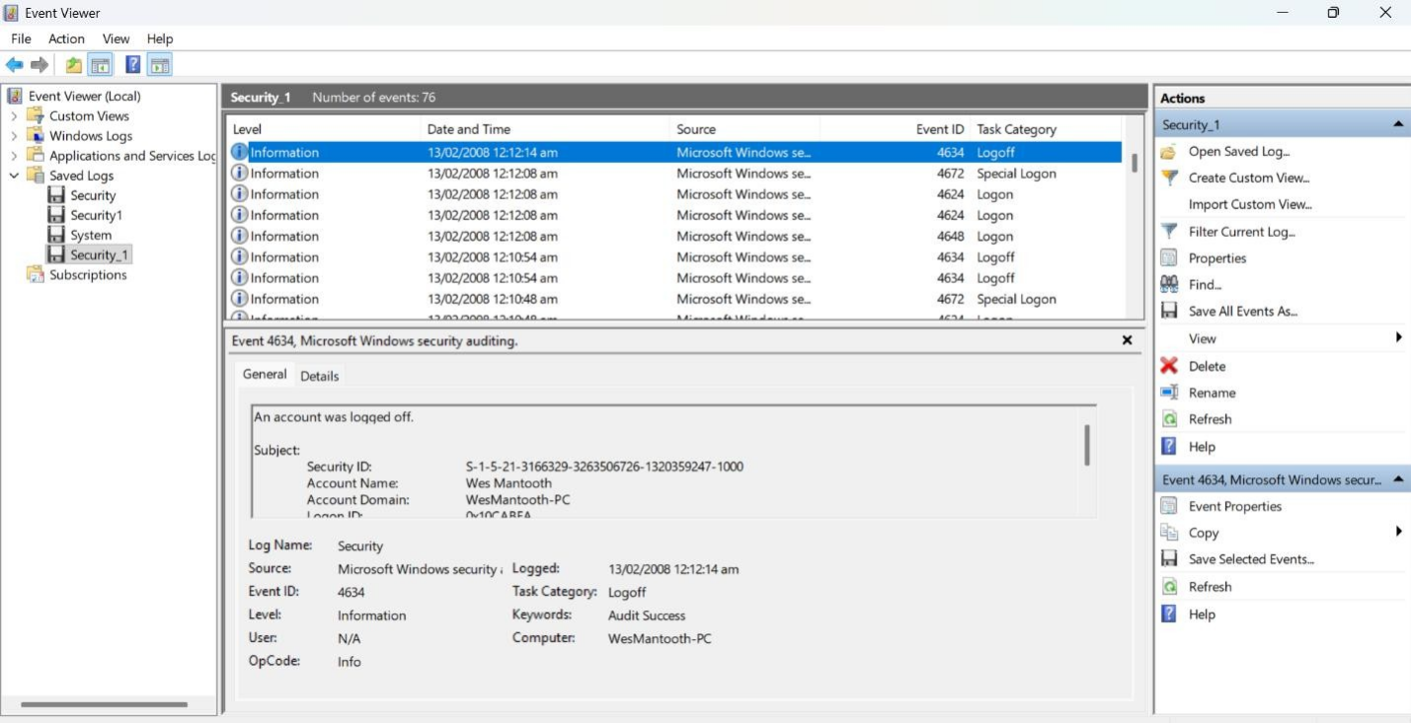

3.3. Conspiracy & Communications
Email artifacts revealed direct links to a fraud ring.
- Email Contacts Identified:
  - chkwasher@comcast.net (Note: Explicit alias linked to the crime)
  - dollarhyde86@comcast.net
  - smee.rox@gmail.com

- Communication Subject Lines: Emails containing subjects such as "New Venture" indicate organized coordination.
- Alternative Aliases: The suspect utilized Yahoo Messenger under the alias incisorman420, providing a pivot point for cross-platform identification.
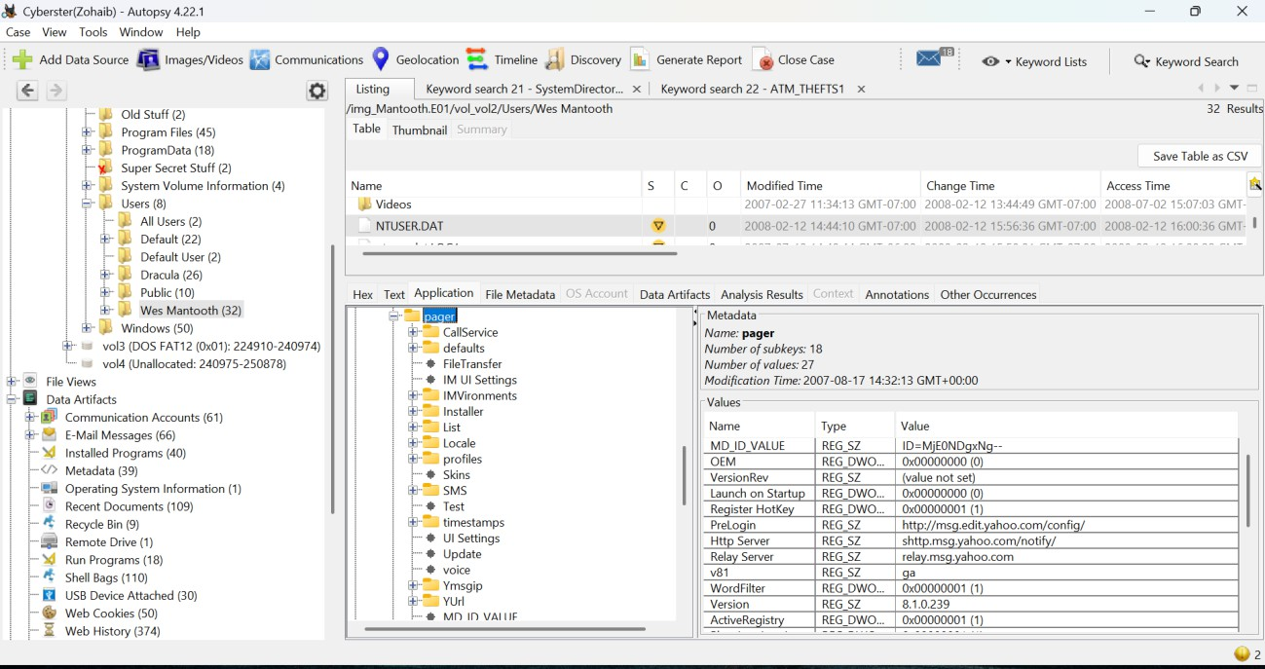

3.4. Operational Security & Remote Access
The suspect possessed tools designed to hide activity and facilitate remote coordination.
- Anti-Forensic Tooling: The machine contained encryption tools, steganography software, and disk wiping utilities.
- Remote Access: RealVNC was installed on the system. The access password was set to the trivially weak string: password. This introduces the high probability that co-conspirators had remote access to the forgery environment.
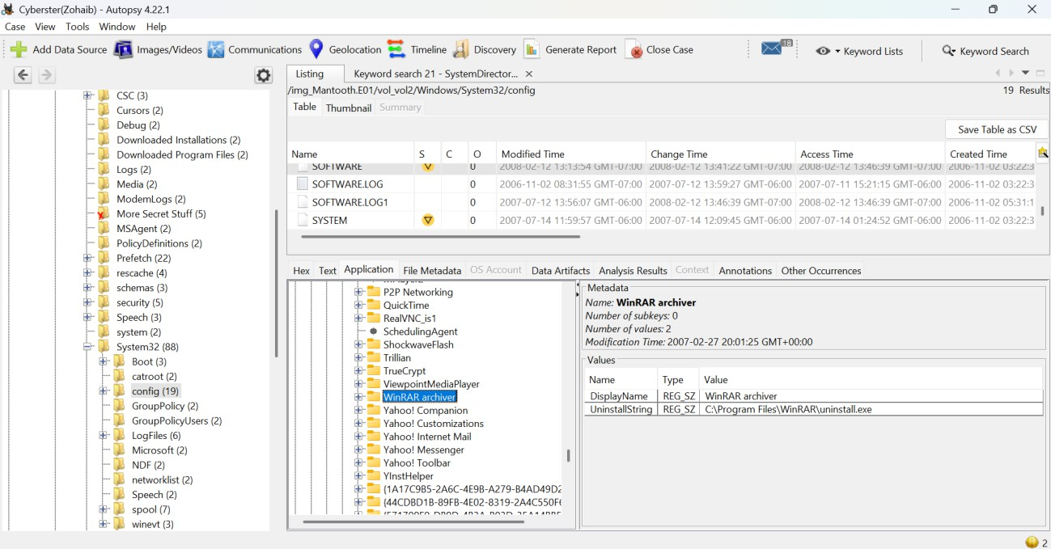
Program Name | Installation Timestamp (UTC) | Investigative Significance
WinRAR archiver | 2007-02-27 20:01:25 | Compression tool, could be used to archive and exfiltrate stolen data.
TrueCrypt | 2007-04-11 01:37:31 | Encryption software. Actively running . Suggests hidden encrypted volumes.
Trillian | 2007-02-27 19:39:25 | Multi-platform instant messenger. Could be used for covert communications.
RealVNC | 2007-04-11 17:24:00 | Remote desktop tool. Confirms VNC installation matching the password found.
Yahoo! Messenger | 2007-02-27 20:28:14 | Primary chat platform for suspect, matching the incisorman420 alias

4. Investigative Conclusion
The forensic record recovered from Mantooth.E01 unequivocally supports a charge of deliberate and organized financial fraud.
Wes Mantooth possessed the physical capability (Epson photo printer, forgery templates, encryption software) and the intent (search history, ATM research) to execute the crime. Furthermore, the established communication channels (chkwasher@comcast.net) and remote access configurations confirm this was not an isolated incident, but an organized scheme requiring accomplices.

